EMBEDDED PRODUCT DESIGN

ASSINGMENT – I

(HONOURS)



REPORT

eMERGENCY VEHICLE DETECTION SYSTEM

Jeffin George Johnson | S8 ECE-B | RET16EC089

29th May 2020

# Introduction:

The Emergency Vehicle Detection System is an embedded product that is installed in high traffic junctions to provide an efficient path to emergency vehicles without wasting critical time blocked in busy junctions. It detects the vehicle sirens early on and clears the traffic in the junction by controlling the traffic lights. It employs an Artificial Neural Network which is trained to detect the particular vehicle siren and differentiate it from normal traffic noises. The system wirelessly communicates to the traffic control unit to change the traffic lights.

The detection system is placed at a certain distance from the traffic junction and comprises of the essential decision-making components of the system. The system includes a microphone, a Raspberry-Pi unit and a long-range Wi-Fi module.

## Block diagram:

LED Display



Traffic Light Control System

Acoustic Sensor -Microphone

Raspberry-Pi

Module

Long-Range Wi-Fi Module

**OUTPUT UNIT**

**DETECTION AND CONTROL UNIT**

# Architecture:

Raspberry-Pi Unit

Wireless Communication Module

Microphone Audio Input

CPU

Memory

### Microphone

Sirens from Emergency Vehicles are detected by capturing all the noises from the junction and extracting certain unique features associated with sirens. These sounds are captured via a microphone which convert sound into an electrical signal. This analog input is given to the Raspberry-Pi module where it is converted to digital and features extracted. The microphone used is a high-quality electret (condenser type) microphone, of which, four of them, placed at the four ways leading to a junction are unidirectional, while the one placed at the center is omnidirectional.

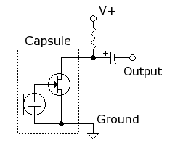An electret microphone is a type of electrostatic capacitor-based microphone, which eliminates the need for a polarizing power supply by using a permanently charged material. It is a form of condenser microphone, but utilizes a dielectric that remains permanently charged, thus removing the need for an external supply. It is widely used as a cheap but effective microphone. High quality versions available at the low end of the market are used in this system. The dielectric used retains a permanent charge equivalent to around 100 volts. Electret material is any dielectric material that has a quasi-permanent electric charge or dipole polarization. These materials generate permanent internal and external electric fields and can be effectively used to charge other electrical components, such as capacitors. Thus, it is a ferroelectric material that has been permanently electrically charged or polarized. Due to the high resistance and chemical stability of the material, the electrical charge will not decay for hundreds of years. The electret material is typically Polytetrafluoroethylene (PTFE) plastic in film form or in solute form.

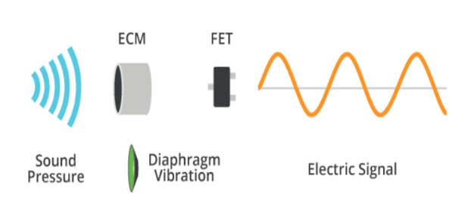The working principle of an electret condenser microphone is that the diaphragm acts as one plate of a capacitor. Vibrations produce changes in the distance between the diaphragm and the back plate. The voltage maintained across the diaphragm and the back-plate changes with the vibrations in the air. This change in voltage is amplified by the FET and the audio signal appears at the output, after a dc-blocking capacitor.

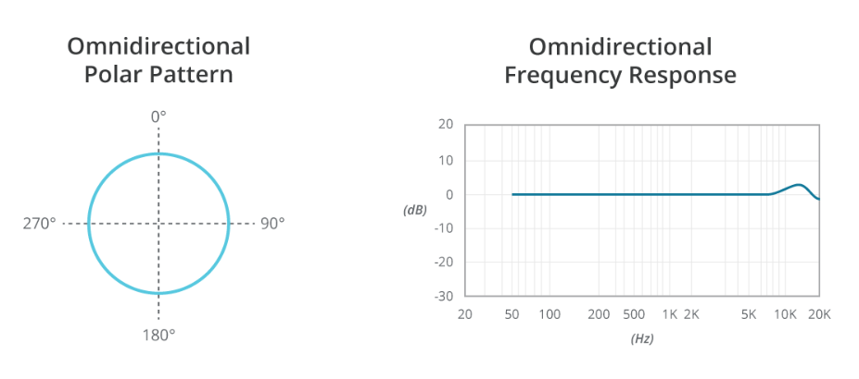The microphone used at the center is omnidirectional as it acts as the common tracking mic for vehicles coming in all directions. A microphone’s directionality or polar pattern indicates how sensitive it is to sounds arriving at different angles about its central axis. Omnidirectional microphones are designed to receive vibrations from virtually any direction. The diagram illustrates the pattern of how the microphone receives sound. The microphone faces upward (toward the viewer) and sound intensity for a particular frequency is plotted for angles radially from 0° to 360°.

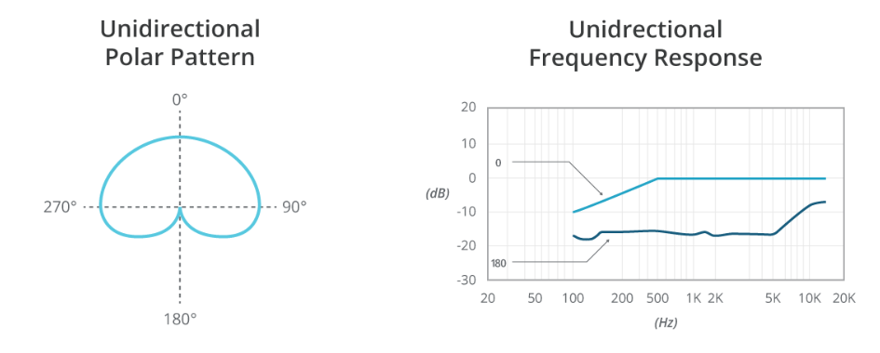The other microphones are unidirectional to prevent sirens from other directions from interfering. Unidirectional microphones are sensitive to sounds primarily from one direction and eliminate unwanted background noises. The diagram illustrates the pattern of how the microphone receives sound. The microphone faces upward and the sound intensity for a particular frequency range is plotted for angles radially from 0° to 360°. These are the cardioid-type polar patterns which vary greatly in their directionality and null points of maximum rejection.

### A circuit board Description automatically generatedRaspberry-Pi

Raspberry Pi 3 has an ARMv8 1.4 GHz multi-core processor, a Video-Core IV GPU and with 1 GB of RAM. it uses an SD card for its operating system and data storage, all packed in a credit card size board. Other models like B+ received two more USB ports, an updated 40-pin GPIO layout, and a micro-SD card slot for loading the operating system., the model B+ was cheaper and offered more connectivity than model B, Making it an ideal choice for this system. The older models used ARM1176JZF-S Processor with typical clock size of 700 MHz, preforming at approximately 40 MFLOPS which can be overclocked to 1GHz without any issues. The Video-Core IV graphics processor with 1 billion pixels per second. It includes multiple built in I/O ports, 100 MB/s Ethernet port, HDMI port, RCA port and an Audio Jack. It used the ARMv6 Architecture with 32-bit RISC which had Branch Prediction with Return Stack. It had 8 Pipeline Stages with 33 general purpose 32-bit registers and 7 dedicated 32-bit registers

The RISC architecture has a low transistor count that enables low power consumption/heat production. This Architecture allows for various Unix OS’s. Raspberry Pi can utilize nearly all Linux distros.

The CPU consists of: ● Integer Core ● Load Store Unit (LSU) ● Prefetch Unit ● Memory System ● Level One Mem. System ● Interrupt Handling ● Coprocessor Interface ● Debug. ● Instruction cycle summary and interlocks ● AMBA AXI Interface ● Coprocessor Interface ● Instruction Cycle and Interlocks ● Vector Floating-Point (VFP) ● System Control.

The Integer Core processes integer values with 40 total 32-bit registers. It has three Pipelines: ALU, MAC, and Load/Store. The ALU handles all arithmetic, logic, shift, and saturation operations while the MAC handles all Multiply operations such as 32x16 multiplier and accumulator. The Load/Store Unit handles all load and store operations sent from the Integer Core and decouples these instructions from the MAC and ALU pipelines. The Prefetch Unit handles all instruction calls. It utilizes both types of branch prediction. When combined with the Branch Target Address Cache (BTAC) results in nearly zero wasted cycles (Dynamic). It also handles branches not in BTAC with normal branch predictor (Static). The Memory Management Unit organizes all memory calls, in order to make them more efficient, lowering system delays. The Vector Floating Point Coprocessor (VFPC) handles Floating Point Operations, as the core of process is integer. Both Single and Double Precision. The Vector Interrupt Control (VIC) Interface handles all interrupts and deals mainly with external systems. It also has request signals that allows faster interrupt.

Raspberry Pi supports multiple Linux distributions like Ubuntu, Openelec, OSMC. The language used for this system is Python. Two main programs are used to run this system:

* Training & Evaluation: In this program, the Artificial Neural Network is trained by using the pre-recorded audio clips of the particular siren to be detected. Large dataset of pre-recorded clips is given into the neural network and corresponding weights and biases are updated in order to accurately detect the siren. 30% of the data is used for the evaluation stage
* A screenshot of a cell phone

  Description automatically generatedReal-Time Detection: This program is run in real-time to detect the emergency vehicle siren by separating small frames of sound and giving them as input to the trained neural network created in the above program. The output is given by a control signal generated based on a probability threshold set earlier. This control signal is wirelessly transmitted to the traffic control unit to change the signal to green.

It has 3 Instruction Sets:

* 32-Bit ARM for single instructions that can handle data and organize processor segments.
* 16-bit thumb which is specialized in branch range and address space. Also used with ARM for rapid interrupts and used for digital signal processing
* 8-bit java for Jazelle technology that deals with complex java bytecodes

The CPU Cache Organization follows Harvard Implementation that allows simultaneous access for program memory and data memory. The write policy can be either writeback or write-through. The replacement policy is either pseudo-random or round robin (controlled by RR bit).

The Raspberry Pi is equipped with one SPI bus that has 2 chip selects. The BCM2835 on the Raspberry Pi has 3 SPI Controllers. Only the SPI controller is available on the header:

● Master mode ● Standard mode ● Bidirectional mode ● LoSSI mode (Low Speed Serial Interface)

### Long Range Wi-Fi Communication Module

In order to send control signals from the Raspberry-Pi System to the traffic light controller located at a considerable large distance, long range Wi-Fi is used. It can connect the device to any standard Wi-Fi router and access internet directly wirelessly or through a LAN. The high-power bidirectional Wi-Fi receiver will help improve the range of connectivity between any device and a Wi-Fi hotspot. The device's omnidirectional antenna is used to communicate to, and from the Wi-Fi hotspot that you connect to.

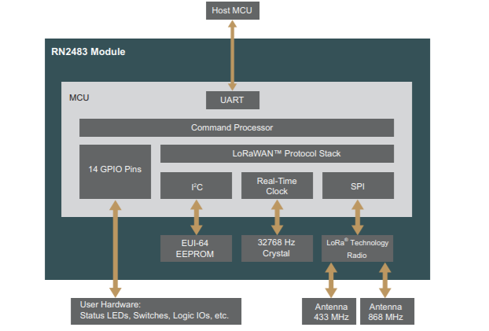Low-Power Long Range LoRa® Technology Transceiver Module Microchip RN2483

Specifications:

* Low-Power Long Range Transceiver Operating in the 433 MHz and 868 MHz Frequency Bands
* High Receiver Sensitivity: Down to -146 dBm
* TX Power: Adjustable up to +14 dBm high Efficiency PA
* FSK, GFSK, and LoRa Technology Modulation
* Up to 15 km Coverage at Suburban and up to 5 km Coverage at Urban Area
* Single Operating Voltage: 2.1V to 3.6V (3.3V typical)
* Temperature Range: -40°C to +85°C
* Low-Power Consumption
* 14 GPIOs for Control and Status, Shared with 13 Analog Inputs

The RN2483 transceiver module features LoRa Technology RF modulation, which provides long range spread spectrum communication with high interference immunity. Using LoRa Technology modulation technique, RN2483 can achieve a receiver sensitivity of -146 dBm. The high sensitivity combined with the integrated +14 dBm power amplifier yields industry leading link budget, which makes it optimal for applications requiring extended range and robustness. LoRa Technology modulation also provides significant advantages in both blocking and selectivity compared to the conventional modulation techniques, solving the traditional design compromise between extended range, interference immunity, and low-power consumption.

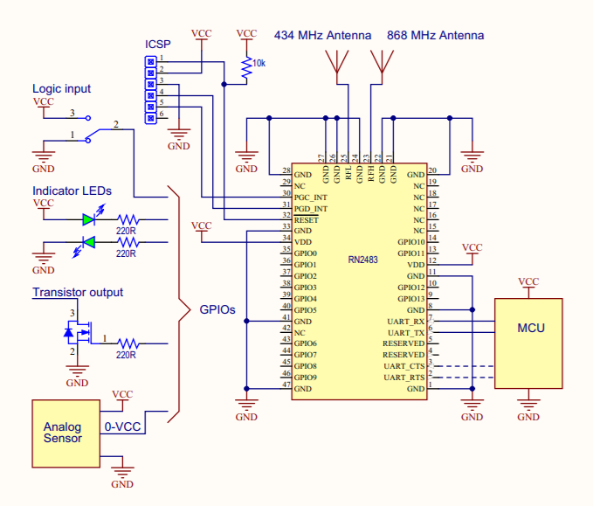

### LED Display

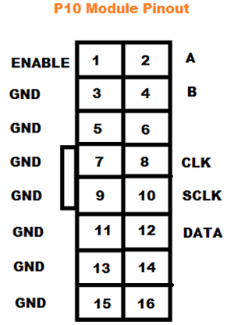A visual indication to the vehicles in the other lanes is given by an LED display indicating that an emergency vehicle is passing through. A P10 LED Display Module is the most suitable for designing any size LED display board. This panel has a total of 512 high brightness LEDs mounted on a plastic housing designed for best display results. Any number of such panels can be combined in any row and column structures to design an LED signboard. A 32x16 module size means that there are 32 LEDs in each row and 16 LEDs in each column. Thus, there is a total of 512 numbers of LEDs present in each module unit.

Features of a P10 LED Matrix Module:

* Brightness: 3500-4500nits
* Max Power Consumption: 20W
* Voltage Input: DC 5V
* IP65 Waterproof
* 1W Pixel Configuration
* High Viewing Angle
* High Contrast Ratio

# Design Documentation – Parameters and their Influence:

|  |  |  |
| --- | --- | --- |
| **INFLUENCE** | **FEATURES** | **DESCRIPTION** |
|  | Salability | Aims to improve Traffic Safety & Emergency Response market |
| Time to market | 5-6 months |
|  | Device lifetime | 18-24 months with regular maintenance |
| Business (Sales, Marketing, Executive Management etc.) | Target Market | Local Government Institutions & Transport Authorities, Road Safety & Public Works Department |
|  | Schedule | 3 months for Design and 3 months for Training & Verification |
|  | Capability | Ability to reduce critical response times of emergency vehicles |
|  | Risks | Cost Overruns |
| Technical | Performance | Artificial Neural Networks aims to accurately detect emergency vehicle sirens and provide a traffic free path |
| Reliability | System is reliable |
| Portability | Semi-Portable |
| Testability | 3-month training and testing period |
| Quality Assurance | Availability | Can be easily installed in any traffic junction or intersection. Also, can be adjusted to different junction designs. |
| Modifiability | Can be further expanded to facilitate inter-junction communication. |
| Features | Re-programmable, Flexible and Accurate. |
| Customers | Performance | Highly efficient |
| Cost | Estimated around Rs 35,000 to Rs 45,000 (for 5 units suitable for a single 4-way traffic junction) |
| User friendliness | Easy installation and Low maintenance cost |

# Customer FAQ:

**Q. How is the product resistant to varying weather conditions?**

**A:** *The product is enclosed in a waterproof casing and installed along the roads leading up to a junction. This prevents water and dust from entering and damaging the product and improving its lifetime.*

**Q. How long does the system override the usual traffic signal functioning?**

**A:** *Depending on the junction, a preset time is given for the vehicle to pass through the junction. The interrupt to the traffic signal exists as long as the emergency vehicle is present in the junction. The central module monitors whether the vehicle has passed and allots additional time if required.*

**Q. What are the risks of false detection?**

**A:** *The system has a high accuracy rate compared to other similar methods of execution. The use of Machine Learning and Artificial Neural Networks make this system a foolproof detection technique.*

**Q. How is the problem involving multiple emergency vehicles approaching the junction solved?**

**A:** *When multiple emergency vehicles approach a junction, preference is given to vehicle that arrives first. The central control unit monitors whether the vehicles have passed through before allowing the traffic signal to resume.*

**Q. How well does the system filter out road noises?**

**A:** *The Artificial Neural Network (ANN) is trained using two sets of data:* ● *Emergency vehicle sirens.* ● *Non-Emergency noises. All the road noises including car honks, pedestrian noises and weather-related noises are all used to train the ANN and identify as Non-Emergency Sounds. When both sounds are mixed together, unique features of the siren are extracted to clearly identify the sound and make a decision.*

**Q. Why isn’t GPS positioning of emergency vehicles used to control traffic junctions?**

**A:** *GPS installation on every emergency vehicle involves higher costs and is time-consuming. The number of emergency vehicles on the road is constantly varying. Thus, siren detection was found to be more cost effective.*

**Q. In case of free left turns for Emergency Vehicles at the traffic junction, will the system still interrupt the signal control?**

**A:** *The system will respond as usual to clear the path for the Emergency Vehicle by setting the signal to green irrespective of the direction to be taken by the Emergency Vehicle.*

**Q. Can this product be used in 3-way intersections and junctions?**

**A:** *Yes, the product is adaptable to different designs of junctions and can be modified*

**Q. What are the advantages of this product compared to other products with similar functionality?**

**A:** *Compared to current existing systems this is a much more inexpensive and accurate method of siren detection. It does need expensive camera modules or require widespread fitting of GPS systems on every emergency vehicle. It is adaptable to a different siren sounds in different markets.*

**Q. Can siren of Ambulances, Fire-Engines and Police Cars be used at the same time?**

**A:** *Yes, the product can detect all the sirens that is used in the training without the need for reprogramming.*